- Create a table comparing Agile and Waterfall models across 5 factors relevant to software testing, such as requirements, feedback cycle, tester involvement, documentation, and flexibility.
Ans=>
Factor | Agile Model | Waterfall Model
Requirements | Requirements can evolve throughout development; testing adapts to changes. | Requirements are usually defined and approved early; changes later can be costly.
Feedback cycle | Short, frequent feedback cycles through sprints and continuous testing. | Feedback generally comes later, often after a development phase is completed.
Tester involvement | Testers are involved throughout development, often working alongside developers and product teams. | Testers typically become more heavily involved after the development phase is substantially complete.
Documentation | Documentation is maintained as needed, with greater emphasis on working software and collaboration. | Detailed requirements, test plans, and other documentation are typically prepared upfront.
Flexibility | Highly flexible; testing and requirements can change as customer needs or defects are discovered. | Less flexible; significant changes may require revisiting earlier phases.

- Pick any app you use daily (like Instagram, Zomato, or Paytm) and describe how the testing process would look different if the team used Agile instead of Waterfall. Mention at least 3 specific testing activities or practices that would change.
Ans=> \
Testing activity | Waterfall approach | Agile approach
1. Test planning | The team prepares a detailed test plan after requirements are finalized, often before development begins. | Testers participate from the beginning of each sprint and create/update tests as user stories are developed.
2. Feature testing | A feature such as “Apply Coupon” may be tested mainly after the development phase is completed. | The coupon feature is tested within the same sprint—unit, API, UI, and integration tests can run as the feature is built.
3. Regression testing | A large regression cycle may be performed near the end of the project before release. | Automated regression tests can run continuously in the CI/CD pipeline whenever new code is committed.

- Draw a simple workflow diagram showing the main roles (such as Scrum Master, Product Owner, Development Team, Tester) and ceremonies (like Sprint Planning, Daily Standup, Sprint Review) in a SCRUM process.

Ans=>
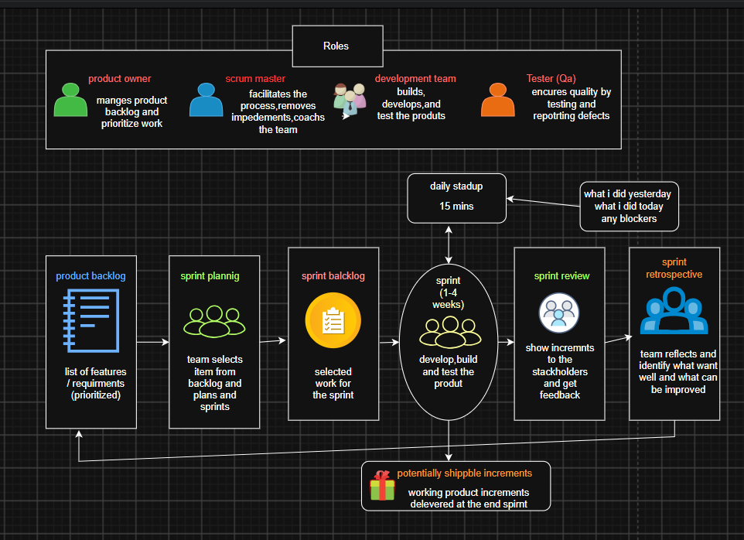

- For a food delivery app (like Swiggy), map out which testing activities should happen during each phase of a typical Agile sprint (e.g., backlog grooming, sprint planning, development, review).<br><br><em><strong>Hint:</strong> Include activities like writing user stories, test case design, test execution, and bug reporting.</em>
Ans=>

Agile phase |  | Testing activities
1. Backlog Grooming / Refinement |  | • Clarify requirements and acceptance criteria • Identify testable conditions and edge cases • Write/refine user stories from a QA perspective • Identify dependencies, risks, and required test data • Estimate testing effort
2. Sprint Planning |  | • Review selected user stories with the team • Define QA tasks and testing scope • Prepare a high-level test approach/strategy • Identify automation opportunities • Break testing work into tasks
3. Development |  | • Design detailed test cases and scenarios • Prepare test data • Create/update automated tests • Review code/unit-test coverage with developers • Perform API testing as relevant • Start testing completed stories as builds become available
4. Sprint Review / Demo

• Validate that completed stories meet acceptance criteria • Provide QA status and test results • Demonstrate important tested functionality when appropriate • Highlight unresolved defects and quality risks

